26a:

1. Max = max(vector) assigns the highest value in the array *vector* to the new variable *Max.*
2. [Max Loc] = max(vector) returns the index (or location) of the maximum value in array *vector.*
3. Max = max(matrix) assigns the highest value in each column of 2D array *matrix* to the variable *Max*.
4. [Max Loc] = max(matrix) returns the indexes (or locations) of the maximum values in 2D array *matrix.*
5. Max = max(matrix) assigns the highest value in each row of 2D array *matrix* to the variable *Max*.
6. Max = max(max(matrix)) assigns the highest value of the highest values of each row in the 2D array *matrix* to the variable *Max.*
7. Total = sum(vector) adds together all the elements in array *vector* and assigns the result to variable *Total.*
8. Total = sum(vector(4:10)) adds together elements 4 through 10 in array *vector* and assigns the result to variable *Total.*
9. Total = sum(matrix) adds together all the elements in each column of the 2D array *matrix* and assigns the result to variable *Total.*
10. Total = sum(matrix,2) adds together all the elements in each row of the 2D array *matrix* and assigns the result to variable *Total.*
11. Total = sum(sum(matrix)) adds together all the elements in each column and then adds together all of those values of the 2D array *matrix* and assigns the result to variable *Total.*
12. Total = sum(matrix(3:6,4)) adds together elements 3 through 6 in the 4th column of the 2D array *matrix* and assigns the result to variable *Total.*

27:

|  |  |  |
| --- | --- | --- |
| -1 | 1 | 18 |
| 10 | -2 | 6 |
| 17 | 12 | 10 |

|  |  |  |
| --- | --- | --- |
| -3 | 5 | -2 |
| 0 | 10 | 0 |
| -9 | -2 | -6 |

|  |  |  |
| --- | --- | --- |
| 6 | 14 | 12 |
| -3 | -7 | -6 |



|  |
| --- |
| 1 |
| 4 |
| 0 |

|  |  |  |
| --- | --- | --- |
| -12 | 6 | -10 |
| 30 | -1 | 15 |

Problem 21

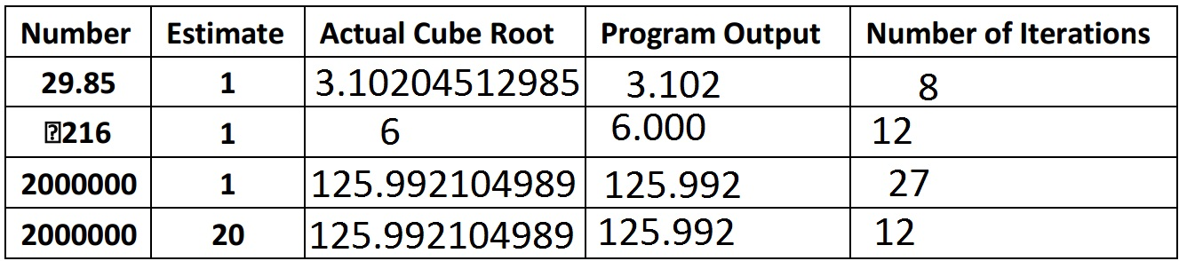

Problem 22

